**Explore Weather Trends**

**Data Analyst Nanodegree project ==1==**

**Date : 19 march 2021**

**Prepared By : Shuaib Elamrity**

**Revision : 2**

**Page 1**

**1.Extract Data from Dataset**

**First I’m Looking for closest city to My Place Where I live on My Country , I fount 2 City (‘Cairo’ , ‘Alexandria’) ,**

**I choose Alexandria Because it’s my City**

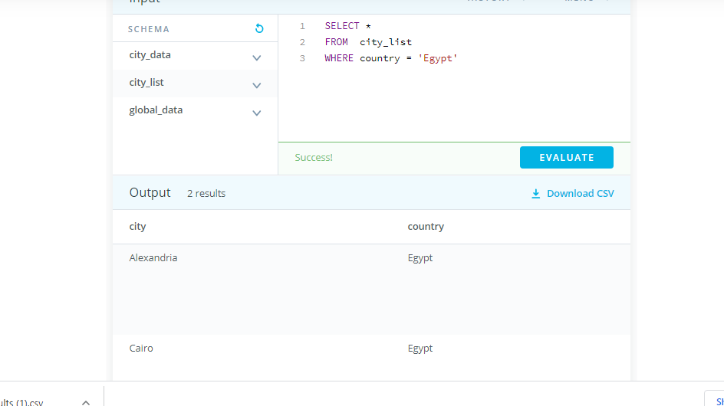

**Figure:1 sql Query (local city)**

**1.(A) Extract Alexandria data :**

Now it is time to extract all the temperature data for the city of Alexandria using SQL Query as follows:

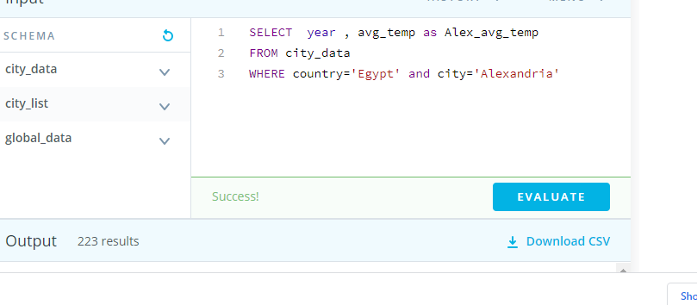

**Figure:2 sql Query (Alexandria data)**

This will return 223 results in total from the year 1791-2013

**1.(B) Extract Global Data :**

Now I will extract the global data which return 223

Results from the year 1791-2013

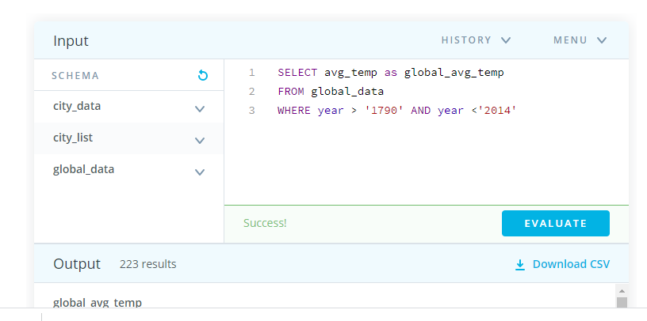

Figure:3 sql Query (global data)

**2. Data manipulation**

Due to fluctuations in yearly averages, it is best to evaluate the data considering the moving average to provide smoother results during data visualization.

The moving average has been prepared on the same excel spreadsheet on a 7-year basis. This is done by calculating the average temperature for the first 7 years (1790- 1796). The same is then repeated from years 1791-1797 and so forth.

The same procedure is performed for both the local city data and global data to obtain data which will be used for data visualization.

Page:3

**3.Visualization**

**BY:EXCEL**

I am now able to plot a line chart to show a comparison between the local city average temperature and global average temperature. This is done by plotting the moving average temperatures on the y-axis and the year range on the x-axis. After inputting the corresponding values on excel, the following line chart is generated.

Figure:4 chart line for (global vs Alexandria) temperature change

Page:4

**4. Observatiopns :**

**From the previous chart, we will see that**

**1.** Alexandria’s weather is much hotter than the global average which :

_Alexandria temperatures average is 20.31

_Global temperatures average is 8.40

……………………………………………………….

**2.** In both cases, we can see that the average temperature is gradually increasing throughout the entire time-frame but when we look at the directorate, the changes in Alexandria's temperature are greater than the changes in global temperature. which :

_Alexandria temperatures range is (22.6 – 18.91) = 3.69

_Global temperatures range is (9.73 – 6.86) = 2.87

…………………………………………………………………………

**3.** If we look to the overall trend for the global temperatures we will see that the world getting hotter

_the average for (1791-1891) is 8.02

_the average for last 100 years is 8.81

…………………………………………………………………

**4.** Does high global temperatures lead to a rise in Alexandria?

I think this, although Alexandria is a coastal city, but it is affected by the global temperature rise. Let's look at the following:

_the average for (1791-1891) is 20.00

_the average for last 100 years is 20.7

……………………………………………………………………………………

……………………………………………………………………………………